Audio Builders Workshop

BREADBOARD KIT

General introduction

### Introduction

This kit is intended as a beginner level kit to introduce you to assembling your own electronic projects. If you received this kit at an AES/ABW event then most likely there are volunteers on hand to answer questions while you follow this guide to assemble the kit.

If you received this kit for assembly at home many general electronic assembly questions can be answered from resources found on the internet.

If you get stuck and need help please post your question on the Audio Builders Workshop’s Facebook page <https://www.facebook.com/groups/AudioBuildersWorkshop/>

Looking for the projects? Please see:

<https://github.com/AudioBuildersWorkshop/BreadboardKit/>

### About the audio builders workshop (ABW)

The ABW is a working group of the Boston Chapter of Audio Engineering Society. The ABW promotes interest in electronics construction and design for applications with audio. In addition to kit building the ABW sponsors all day seminars on various technical topics related to audio and recording of audio. The Boston AES also runs shorter (1 to 2 hours) lectures, company visits, and networking events once or twice a month. All ABW and Boston AES events are free to attend, though there are materials fees for purchasing kits.

Many of the events are posted on the ABW You Tube channel, including a substantial back catalog of talks: https://www.youtube.com/audiobuildersworkshop

### About this kit

The kit contains parts needed to create a wide range of circuits that are of interest to audio builders. The parts list includes both op-amps and transistors along with a wide range of passive components.

The intent is for those new to electronics building to use this kit as a jumping off point for both tinkering with the provided examples to develop an understanding of how the circuits operate as well as moving up to DIY audio kits that are assembled by soldering components on to a PCB (Printed Circuit Board).

We assume a first time builder; this document as well as the directions for the 555 metronome and the CMoy headphone amplifier have extra explanation included. Documents for the other circuits assume some experience or that you’ve built the two examples that include the extra explanatory materials.

As a first time builder you may not know much about bread boarding; we refer you to other resources to provide more information about this as you, dear reader, might perhaps prefer videos over reading about these things.

### More info

<https://www.audiobuildersworkshop.com/>

Licensed under Creative Commons License

### WARNING

This electronics kit has lots of parts with small pointy wires on them. Eating them would be a really bad idea, as well as poking them at your own or someone else’s body. Don’t leave the parts out where small children, pets, etc. might mistake them for skittles. Use common sense, eh?

.

# Getting ready

Set up a workspace where you can organize the parts and the documentation without sending the parts flying across the room.

Tools needed:

|  |  |
| --- | --- |
| * Wire strippers * Wire cutters * (optional) Needle nose pliers * (optional if you have good eyes) Magnifying glass | * (optional) component lead bender * (optional) voltmeter for testing * (suggested) Grounded ESD wrist strap |

Please read through this manual and the instructions for the project you intend to build before starting assembly so you understand how the steps proceed before you start. We know you won’t, but don’t say we didn’t warn you!

We listed wire strippers and cutters separately as while most wire strippers have cutters built in, they are not as good as actual diagonal wire cutters, which cut more cleanly than the scissors cut of most wire strippers.

## Precautions

The integrated circuits (IC) used in the project can be damaged by static electricity. You should assemble this at a static free workstation. If you don’t have that you should touch a metal object before picking up any components. If you feel a static discharge then your work area is definitely not static safe and you should at least get an ESD grounding wrist strap. Even if you don’t feel a static discharge your body may accumulate a charge that can damage the IC used in this project; touching a large, grounded metal object first reduces the chance of damage but is not a substitute for proper static control.

# Parts identification - Introduction

Abbreviations used:

uF = micro farad (one millionth)

nF = nanofarad (one billionith)

pF = picofarard (one million millionth). Usually pronounced “puff”.

K = 1,000 (thousand)

M = 1,000,000 (million)

Ω = ohm  
op-amp = Operational Amplifier

Pot = Potentiometer, Variable Resistor

W = Watt

## Notes

Use caution when bending component leads to not damage the component.

### Polarized components

There are several components that must be installed in a particular orientation to avoid failure.

(Electrolytic) capacitors. These are marked with a “-“ (minus or negative) stripe on one side, meaning that the side opposite the “-“ is the “+” (plus or positive) side. For historical reasons the PCB labels the “+” connection.

Diodes. There are two different diodes used. Both have a band marking the cathode (“-“) end and should be installed as indicated on the PCB.

LED. The cathode end is marked by either a flat side or a small notch.

IC. One end of the chip may have a notch in it, or there will be a round dimple/marking to indicate pin 1. On the PCB the notch and dimple are both marked. (different vendors mark their parts differently)

### Identifying resistors by their color code

Hold the part so the grouped colored bands are on the left and note the colors. The ones in this kit have the 4 band code. It can actually be a bit difficult with some resistors to tell which end is which and to make out the colors. An ohm meter is a good way to check that you’ve read the value correctly, but keep in mind the tolerances (+/-5% on some) when determining the value.

You can learn the details of reading color codes on line, for example <https://www.digikey.com/en/articles/techzone/2017/apr/big-boys-race-young-girls-violet-wins-resistors-color-codes>

We’ve copied the chart from that website in to this document.

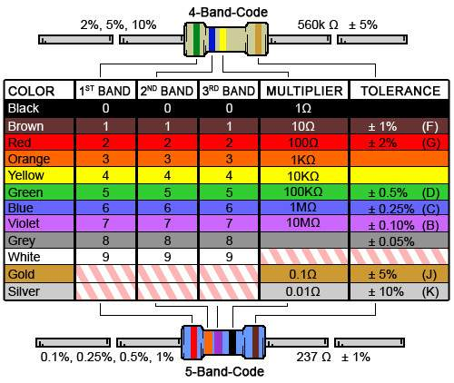

This guide will identify the resistors in detail later so you don’t need to worry about understanding this now.

## Part identification versus reference designator

When we refer to the *value* of the part it’s typically something like its resistance (described in units called ohms) or its capacitance (in units called farads, though in this design microfarad part values). Other parts are identified by a type number (for example 1N4004 for a diode).

The values/identifiers identify the part, but not where to install it on the protoboard. For installation location values referred to as *reference designators* are used. Typically, the reference designator (ref-des for short) is a letter followed by a number. The letter identifies the type of part (R = Resistor, C = Capacitor, etc) and the number is just a sequential ID. These reference designators are used on the schematics to identify each specific part.

While the designs provided with these kits don’t require understanding how to read a schematic, we include the schematics with the intent that you can develop that so that if you find schematics for projects on the internet you will understand how to build them on the breadboard.

The relationship between the ref-des and the part value is specific to a particular circuit design. A table is needed to map between the two. In this design we have placed the value on the PCB silkscreen (the white lettering) to make this process easier.

## Bending lead foraxial components like resistors and diodes

You will need to carefully bend the leads for the axial leaded components, which are resistors and diodes in this kit. You can do this with your fingers, with a component lead bender, or with needle nose pliers.

While you can make the breadboard look neat with leads bent to the exact spacing needed in the circuit and then trimming the leads, you may find that in the next project the leads need to be spaced differently but are not long enough. So probably not a good idea to cut the leads, and keep the bends gentle enough that you can straighten them again.

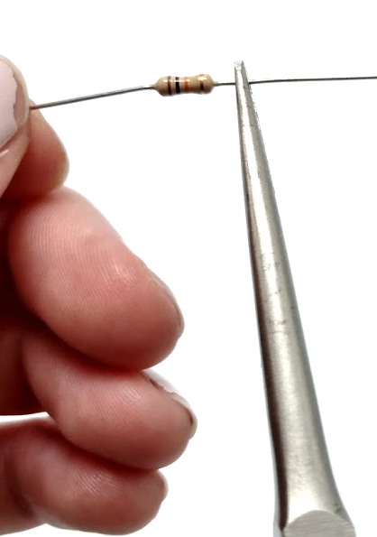

Figure 1 Bending the leads with needle nose pliers

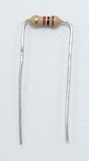

Figure 2 After bending both sides – probably bent sharper than you want to bend them for re-use!

Once the leads are formed the component can be inserted in to the breadboard to check that you have the spacing correct.

# Part tricks

While ABW projects will select from available parts in the kit, you might find a schematic that you want to build that calls out for resistor or capacitor values that you don’t have. In some cases the exact value isn’t critical and the circuit will still function with part values that are as much as 20% from the indicated value.

Even if knowing this there will be some values you can’t make. This is where knowing that placing parts in series or parallel combinations to get a specific value comes in handy. You can find calculators on the net that can compute the value of parallel combinations of resistors (which create a resistance of a lower value) such as this one:

<https://www.calculator.net/resistor-calculator.html>

Resistors connected in series add in value.

For capacitors the opposite is true, capacitors in parallel add in value, and ones in series are the sum of the inverses. Again an online tool can be handy to do the math. We don’t know of a tool where you could tell it all the values you have and it will provide an answer for a given target value.

# Parts identification -kit parts

This section only provides details on identifying the parts included in the kit.

While kits are usually made with parts form the same manufacturer so look like these pictures, there is a chance that we had to substitute parts and the will have a different color or appearance than what is pictured here.

For more information about the parts please see the parts list that was included in your kit and/or posted online.

Some of parts are provided attached to a paper carrier. Pull them from the carrier, and you may need to wipe the ends that were attached as the adhesive residue will interfere with making connections.

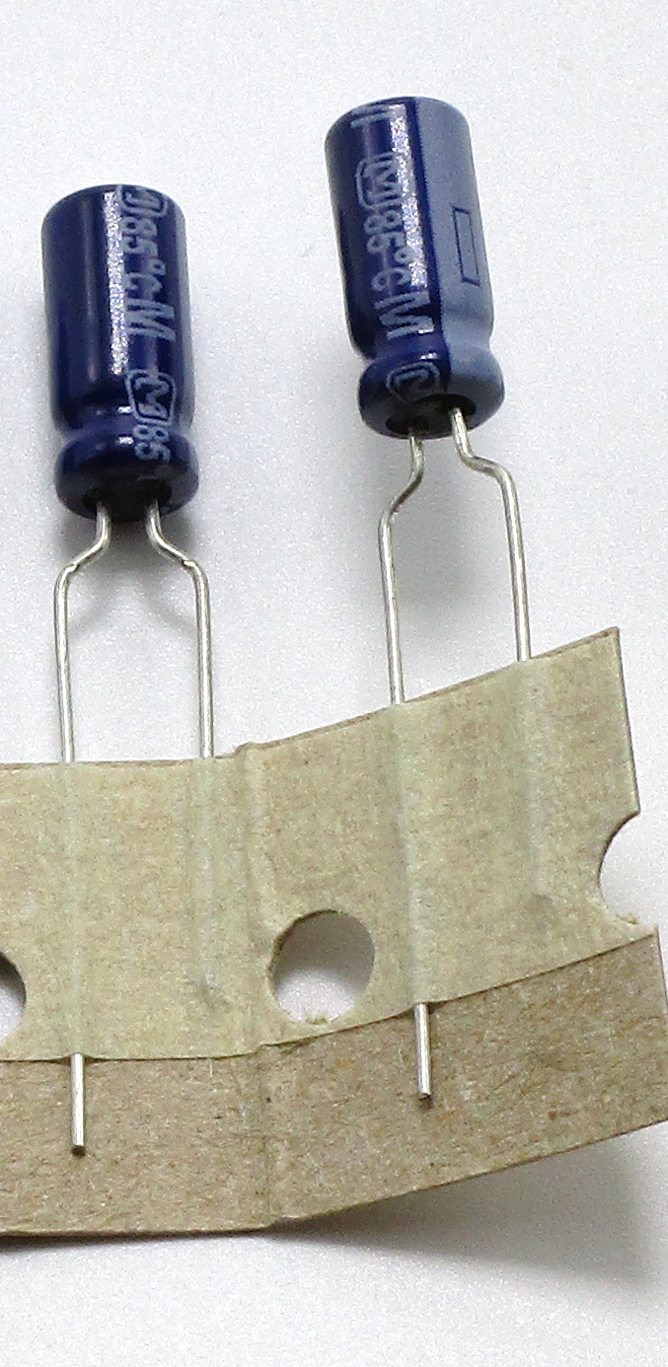

All of these parts have either a maximum voltage rating or a maximum power rating. With the 9V battery powering the circuits you will normally not exceed these ratings for the parts. If you move on to more advanced circuits though then this must be taken in to account. The parts list provided with the kit can be used to look up details on the parts specifications.

## Resistors

### Fixed resistors

The kit has 8 eight each of all values except for the 10 ohm, which has 4. All resistors are 1/4W except for the 10 ohm one is 1/2W. They are carbon film type, which are OK for non-critical audio use. High performance circuits would normally use metal film resistors.

|  |  |  |  |
| --- | --- | --- | --- |
| 10Ω: Brown Black Black  Larger than the others | 100Ω:  Brown Black Brown | 330Ω:  Orange Orange Brown |  |
| 1KΩ (1,000):  Brown Black Red | 2.2KΩ (2,200):  Red Red Red | 4.7KΩ (4,700):  Yellow Violet Red |  |
| 10KΩ (10,000):  Brown Black Orange | 15KΩ (15,000):  Brown Green Orange | 22KΩ (22,000):  Red Red Orange | 47KΩ (47,000): Yellow Violet Orange |
| 100KΩ (100,000):  Brown Black Yellow | 390KΩ (390,000):  Orange White Yellow | 470KΩ (470,000): Yellow Violet Yellow | 1MΩ (1,000,000):  Brown Black green |

The schematic symbol for a resistor is:[1]

https://upload.wikimedia.org/wikipedia/commons/thumb/2/26/Resistor%2C_Rheostat_%28variable_resistor%29%2C_and_Potentiometer_symbols.svg/235px-Resistor%2C_Rheostat_%28variable_resistor%29%2C_and_Potentiometer_symbols.svg.png

### Variable resistors

There are two values of variable resistors included in the kit, and 2 each of the two values for a total of 4. The 10K ohm ones have a 103 stamped on the side, which means the value is 10 with 3 zeroes after it, or 10,000 ohms or 10K).

The 1M ohm ones have 105 stamped on the bottom, which means the value is 10 with 5 zeroes after it, or 1,000,000 ohms or 1M).

You can also tell them apart as in most kits the 10K one has a longer shaft.

The middle terminal is the “wiper” terminal or the one that moves to change the resistance. This is shown in the schematic symbol as the terminal with the arrow on it.

https://upload.wikimedia.org/wikipedia/commons/thumb/2/26/Resistor%2C_Rheostat_%28variable_resistor%29%2C_and_Potentiometer_symbols.svg/235px-Resistor%2C_Rheostat_%28variable_resistor%29%2C_and_Potentiometer_symbols.svg.png

The taper refers to the rate of change per unit of rotation of the knob. Linear means exactly what it implies, the relationship is linear. Audio taper changes the value logarithmically which corresponds to the way we perceive loudness, so audio taper pots are commonly used for volume controls.

|  |  |
| --- | --- |
| Pot, 10 K ohm, Audio taper | Pot 1M ohm, Linear taper |

## Capacitors

Non-polarized capacitors can be installed in either orientation.

Polarized capacitors must be installed with the positive and negative terminals connected to specific places in the circuit.

### Non-polarized

The small blue ceramic capacitors are stamped with a value but are difficult to read. There are two typos of 0.1 uF capacitors in the kit. One type is ceramic, the other is film (you can google to find out more). The 0.1 uF ceramic caps are meant for non-audio (i.e. not in the circuit path of audio signals) use. All of the other capacitors in the kit are OK for audio use. OTOH if making a distortion circuit the 0.1 uF ceramic one will add to the effect slightly.

The numbers stamped on the small parts is the capacitance in pF, where the 3rd digit tells you how many zeroes to add. The symbol for a non polarized cap has two parallel lines.

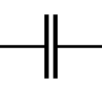

|  |  |  |
| --- | --- | --- |
| 100 pF  Marked with 101 | 470 pF  Marked with 471 | 1 nF (1000 pF) |
| 4.7 nF (4,700 pF)  Marked with 472. | 22 nF (22,000 pF)  Marked with 223 | 47 nF (47,000 pF)  Marked with 473 |
| * 1. uF (100 nF)   Marked with 104 | 0.1 uF (100 nF) film | 0.47 uF (470 nF) Film  Marked with u47 |

### Polarized

Polarized capacitors have a stripe indicating the negative (-) side. They are large enough that the values are imprinted on the case.

The schematic symbol for a polarized capacitor has a marking on the positive (+) side. Note this is opposite the marking on the case.

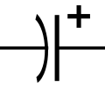

|  |  |  |
| --- | --- | --- |
| 2.2 uF (2,200 nF) | 22 uF (22,000 nF) | 220 uF (220,000 nF) |

Use you can tell they look very similar (don’t count on the 2.2uF actually being red in your kit) and you must therefor check the value printed on the case.

## DIODES

The part number for the axial diodes does not indicate any intrinsic property of the device.

Diodes have a band that indicates the cathode.

https://upload.wikimedia.org/wikipedia/commons/thumb/b/b4/Diode_symbol.svg/120px-Diode_symbol.svg.png

For the LEDs the cathode is indicate by a notch or flat side in the case.

Diodes are polarized in that if you install them backwards your circuit will not work because they only allow current to pass in one direction.

|  |  |  |
| --- | --- | --- |
| Diode (1 amp) 1N4001 | Diode small 1N4148 | Schottky Diode BAT43 |
| LED – Green | LED – Red |  |

The 1N4148 and the BAT43 look very similar. There will be the part number on at least one of the parts.

The 1N4001 part may be marked with 4001, 4002, etc. These can all be used interchangeably in this kit.

Figuring out which side of the LED is which can be difficult. Luckily if you install it backwards there’s no harm done. If using it as an indicator it won’t light. If using it in a distortion circuit (where it generally will not light up) you most likely will just get a different distortion effect.

## transistors

The kit includes 5 different types of transistors. The part number does not indicate any intrinsic property of the device. Transistors can be thought of as being polarized in the same sense that diodes only let current pass in one direction. You can swap two different NPN transistors, but you can not swap a NPN and PNP and end up with a working circuit. It’s within the range of possibilities that if you connect it incorrectly you will damage it.

|  |  |  |
| --- | --- | --- |
| MPSA42 NPN | MPSA92 PNP | 2N3904 NPN |
| BC550 NPN | BC560 PNP |  |

As you can see they all look the same, so you must check the part number stamped on them. Some may only show the number, like 42 for a MPSA42A.

The pinouts of transistors is not consistent so if you use other parts you need to look at the datasheet to verify the pinouts match the ones used here.

**MPSA42, 2N3904, BC550 (NPN)**

 

1 = Emitter, 2 = Base, 3 =Collector

**MPSA92, BC560 PNP (note direction of arrow on emitter)**



## ICs

This component can be damaged by static electricity.

Pin 1 is indicated by a round circle and/or a divot on one end of the package. If there’s a divot on one end then with that on the left side pin 1 is the lower left pin. On the schematics the ref-des for ICs is starts with a U.

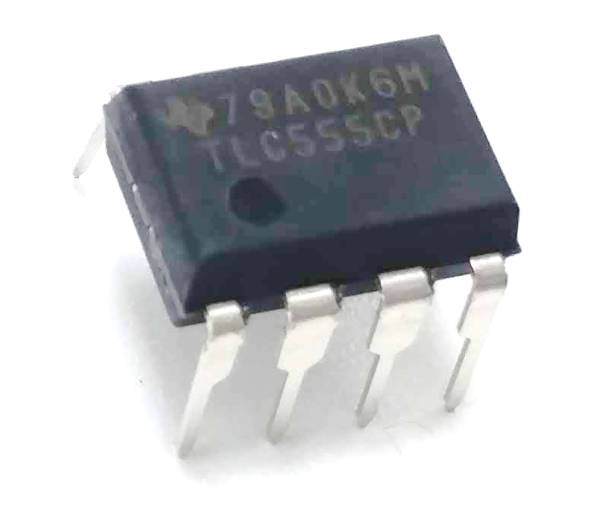

Pin 1 indicator

It is critical to install the IC correctly as installing it backwards may release all of the special magical smoke inside of the parts.

There are two types of ICs in this kit. One is the 555 timer IC, used to make oscillator circuits. The other is a dual op-amp, used in amplifier, filter, and distortion circuits. They are not interchangeable and will most like produce smoke if you accidentally swap them.

Most dual op-amps can be swapped with other dual op-amps. They may not work optimally, and there are some special ones that will be destroyed, but most dual op-amps for audio use can be used in the exampled provided.

|  |  |
| --- | --- |
| TLC555 Timer | RC4558 Op-amp |

The symbol for an IC depends on its function so we won’t include that here.

It is however important to understand how pins are ordered on a DIP package, which is the technical name[2] for this type of package with two rows of pins. Pins are numbered counter-clockwise, starting with pin 1. We’ll generally keep pin 1 in the lower left corner, so on the 8 pin parts in this kit, the pins look like[3]:

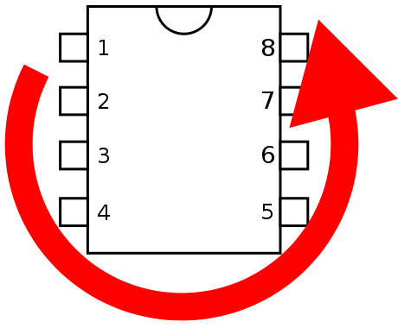

## Other parts

|  |  |
| --- | --- |
| Hookup wire | 9V battery clip |
| Mini phone (stereo) jack. Actual jack may be a different color. |  |

The 1/8” mini-phone jack has three tabs on the bottom that mate to the bread board. When viewed from front/above as shown in the photo below, the signal order is right, n/c, ground, n/c, left. Usually red indicates right and white indicates left, but on breadboard convention is also to use red for the positive power connections. Chose whatever color you want, but if you pick red, don’t wire it to power!

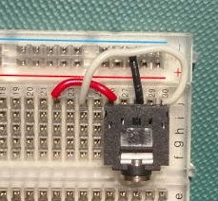

The mini-phone plug has the left on the tip and the right on the ring, and ground is the main (large) part on the jack.

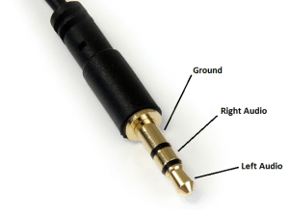http://circuitbasics.com

On a mono plug only the tip signal is present and the rest of the plug is grounded. On input this means there will be no signal from the “right” connection.

On output this means that the right output will be shorted to ground. This is probably a bad idea, so don’t use a mono plug in the output when 2 channels are in use (like the CMoy headphone amp).

Conversely, if the circuit operates on only one channel (for example the 555 metronome or the fuzz circuits) then wire the output to the “left” connector as then a mono jack can be used and the circuit will work the way you expect.

On the schematics the jacks look like this[4]:

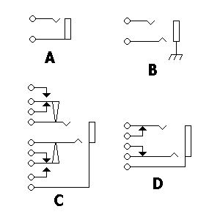

The upper connection would by the tip of the jack (left channel) and the lower connection the ring of the jack (right channel) and the ground connection is indicated by the larger box representing the barrel of the connector. The barrel of the connector is always grounded in the circuits provided in the guide, and that’s indicated in the above by the little “ground” symbol (which can be drawn in other ways too).

## Making up jumper wires

The kits are provided with pieces of 22 gauge solid wire, which is the best size/type for use with breadboards. It’s more convenient to make up a couple different lengths of a few of the colors for a project before you start. Over time you’ll accumulate enough different lengths that you want need to make more. You can also purchase kits of precut wire on line, but they are not cheap compared to just buying a multi-color 6-pack of wire and some wire strippers/cutters.

If your wire strippers are adjustable you should adjust them so that in the fully closed position they do not nick the underlying copper wire. If you do nick the wire cut then end off and try again; nicked wires have a tendency to break off in the breadboard and then it’s annoying to get them out. If you nick them all the time then adjust the strippers to a larger opening and/or make sure you pull the strippers perpendicular to the wire.

Strip back about ¼” (5 mm) of insulation from the wire. For jumpering to an adjacent hole you can forgo leaving any insulation on the wire.

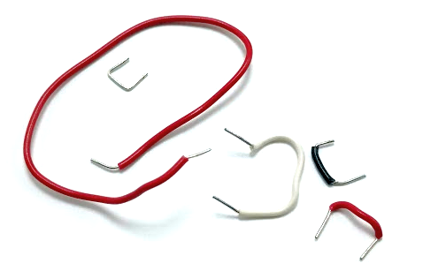

By convention red is usually used for power (positive) and black for ground (negative) connections.

# Overview of assembly steps

## Understanding the breadboard

Breadboards provide a way to connect parts without need to solder them together. This makes it easy to experiments with different parts in a circuit as well as reuse them for different circuits.

There are a lot of on-line resources that can explain breadboards in a lot of details, google will find them for you but here’s a few to get started with.

<https://www.sciencebuddies.org/science-fair-projects/references/how-to-use-a-breadboard>

<https://learn.sparkfun.com/tutorials/how-to-use-a-breadboard>

<https://learn.adafruit.com/breadboards-for-beginners/introduction>

If you’re at a build event we’ll provide some material to help you understand the breadboards; this guide will not include this since others have already created some great material.

### Yeah but…

If your breadboard looks like this:

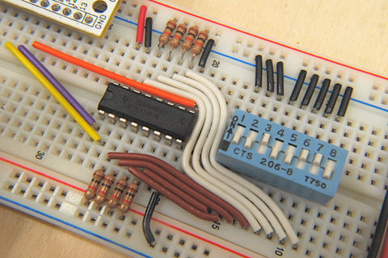

(found on the internet, I won’t embarrass the poster with the URL)

Then you’re DOING IT WRONG!

This is what a typical one looks like:

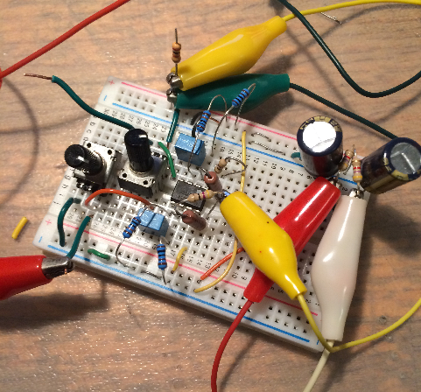

(yeah this person cheated using alligator clips for some connections instead of jumper wire, but you get the idea…it’s about function, not making it look pretty for Instagram)

## Things to think about before you start

Oh heck, it’s a breadboard, you really can’t screw it up too badly…just fix your mistake.

One exception is putting in ICs and transistors backwards, that might break them. So pay really close attention to when you put those parts in.

Polarized capacitors too – while good ones shouldn’t explode we got really cheap fake ones from China for these kits - they can be unhappy if hooked up backwards.

# The good stuff

This document and all of the source files associated with this project are Copyright 2018 by the Audio Builders Workshop (ABW).

<https://www.facebook.com/groups/AudioBuildersWorkshop/>

a working group of the Boston AES

<http://bostonaes.org/>

All materials are licensed by the ABW under the Creative Commons Attribution-Share-Alike license CC-BY-SA: <https://creativecommons.org/licenses/by-sa/4.0/legalcode>



Design and this part of the documentation developed by Clockworks Signal Processing LLC for ABW.



<http://clk.works/>

1. Symbols from <https://en.wikipedia.org/wiki/Electronic_symbol> unless noted otherwise
2. Actually it kind of doesn’t make sense as DIP stands for Dual Inline Package, so “DIP package” means *Dual Inline Package* package. But it’s what we call it. Roger Roger.
3. https://en.wikipedia.org/wiki/Dual_in-line_package#/media/File:Pin_numbering_01_Pengo.svg
4. CC BY-SA 3.0, https://commons.wikimedia.org/w/index.php?curid=80347